FACULTY PROFILE
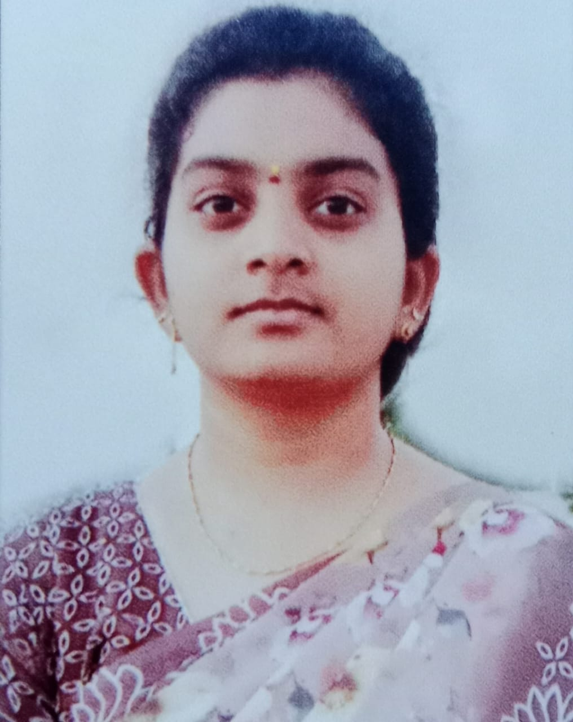
Photo
KAMMILI UJWALA
Department: Electronics and Communication Engineering
College: Seshadri Rao Gudlavalleru Engineering College
Mobile: 8688691264
E-Mail: ujwalakammili2002@gmail.com
__________________________________________________________________
Address for Communication:
College Address: Permanent Address:
Kammili Ujwala Kammili Ujwala
Assistant Professor, D/o Kammili Srinivas,
ECE Department, D.No: 1-159, Main Road Gudivada
Seshadri Rao Gudlavalleru Engineering College, Bantumilli,
Krishna District, Krishna District,
Andhra Pradesh: 521356 Andhra Pradesh: 521324

Academic Qualifications:
S. No | Name of the Degree | University | Percentage of Marks/Grade | Specialization | Year of Pass
1 | M.Tech | JNTUK  University | 8.7 CGPA | VLSI Design and Embedded Systems | 2025
2 | B.Tech | JNTUK  University | 7.9 CGPA | ECE | 2023
3 | Intermediate | Board of Intermediate Education | 9.94 CGPA | MPC | 2020
4 | SSC | Board Of Secondary Education AP | 9.5 CGPA | - | 2017

Professional Experience: NIL
Papers Published in Journals No. : 01
- K. Pooja, K.L.S.M. Likitha, K. Ujwala, B. Vamsy Krishna, “Electronic Passport Verification System Using IOT ”, International Research Journal of Engineering and Technology (IRJET),Volume:10/Issue:03/March-2023.
Workshops Organized No. : NIL.
NPTEL Certification Courses: NIL

Workshops Attended No. : 01
- Attended two weeks workshop on “Design of Internet of Things (IoT)”.
Webinars Attended No. : NIL

Courses completed No. : 01
- Cisco CCNA - Introduction to Networks, Routing and switching essentials, Scaling networks, Connecting networks, Introduction to cyber security, Cyber security essentials.

Training Programs /FDPs Attended No. : 01

- Participated in an online FDP Program on ”AI for Communication and Signal Processing Applications” organized by E&ICT Academy NIT Warangal, in association with Seshadri Rao Gudlavalleru Engineering College from 03rd February to 13th February.

Extra-Curricular Activities: NIL

Declaration
I hereby declare that all the above-furnished information is correct to the best of my knowledge.

Date: 02-06-2025 Signature
Place: Gudlavalleru (Kammili Ujwala)

